Research on Payment methods and Systems

Made by Karina Karushkova

In this research I am going to show how existing apps proceed with payments (different methods of payment) and give examples for Subscription based applications, possibilities; pros and cons. This research was made based on websites and searching the web.

Let’s start by giving examples of famous payment applications that are used today– “Google Pay”, “Apple Pay” and “Samsung Pay”.

“Rather than carrying around cash and cards, just tap your phone to pay. Currently, the three most established systems are from Apple, Samsung and Google, although some wearables from brands like Garmin and Fitbit also offer their own payment systems.” (Savvides, 2018)

1. 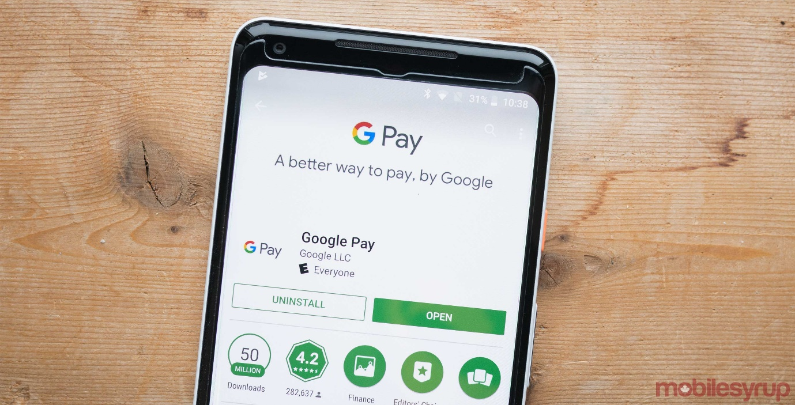In the beginning of January this year (2018), Google announced and merged Android Pay and Google Wallet into a single service known as “Google Pay”.

* “As with prior iterations of Google's payment products, consumers can add most credit, debit and gift cards to the application. You can store loyalty cards as well, helping you maintain reward points.” (Uzialko, 2018)
* 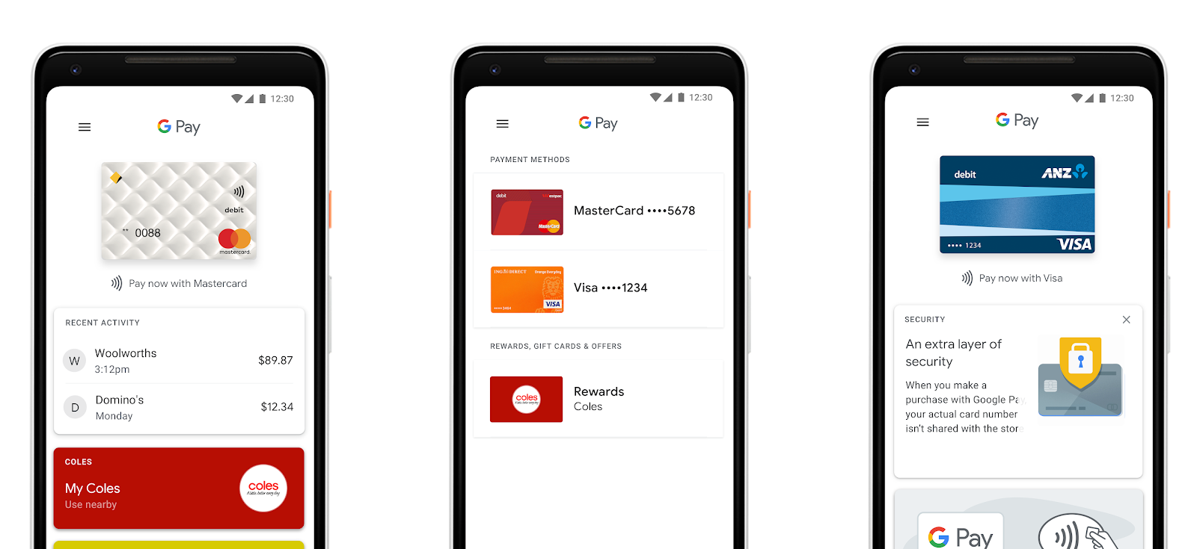“Credit, debit, gift or loyalty cards previously added by consumers to Android Pay or Google Wallet operate as usual and don't need to be re-added to Google Pay, and consumers don't need to add another app to use Google Pay. For users who already have Google payment apps, the only change is the automatic device update to reflect the Google Pay name.” (Uzialko, 2018)
* “Instead of using your actual credit card number and other personal information, Google Pay (like predecessor Android Pay) uses a virtual account number that ensures your personal information is secure on your phone.” (Uzialko, 2018)

The overall usage of this payment app is 7% of the users. (Uzialko, 2018)

1. 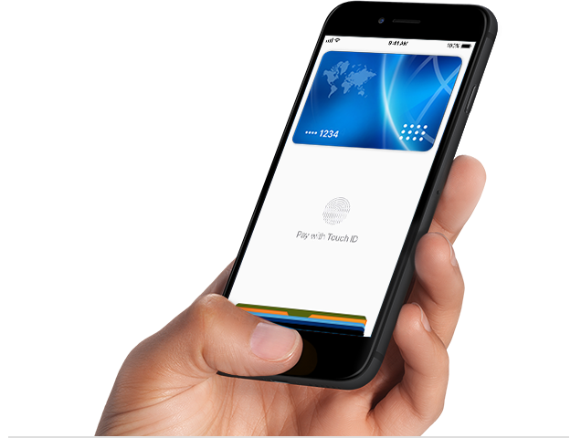Apple Pay is another similar payment application as it is described as “easy, secure, and private electronic payment service” (). IPad, Apple Watch, Mac or Simply an Apple device users can happily use those payment services. All they need is “the latest version of iOS, watchOS or MacOS, Apple's Wallet app, and an Apple ID signed in to iCloud.”. (Uzialko, 2018)

* “In-store, you use Apple Pay on your iPhone or Apple Watch at merchants with a compatible checkout card reader. On the web, in Safari, you use your iPhone, iPad or Mac. Loyalty points, rewards and benefits from your cards continue to accrue when you use Apple Pay.” (Uzialko, 2018)
* “When you make a purchase using Apple Pay, your receipts are kept in your Wallet app, but the transaction information is not stored elsewhere. Every transaction made on your iPhone, iPad or Mac requires authentication with Face ID, Touch ID or your passcode. Your Apple Watch is protected by its unique passcode.” (Uzialko, 2018)
* “When you make an in-store purchase, card numbers and identity credentials aren't shared with merchants, and your actual card numbers aren't stored on the Apple device or on Apple servers either.” (Uzialko, 2018)
* “For online purchases, merchants only receive information that you authorize to share to fulfill your order, such as your name, email address and billing and shipping addresses. Apps that use Apple Pay must have a privacy policy that you can view, which keeps you in control of your data.” (Uzialko, 2018)

The most overall usage is recorded with 13% of smartphone users of the mobile wallet. (Uzialko, 2018)

1. 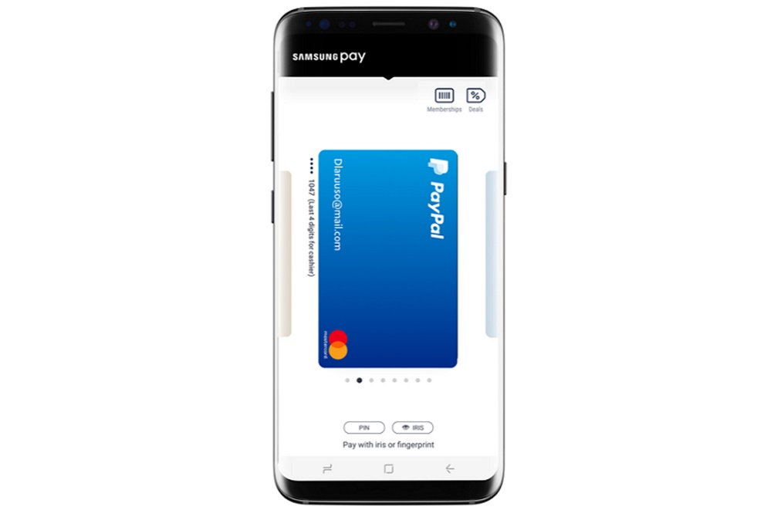“Samsung Pay is much more limited than Google Pay and Apple Pay. This electronic wallet is compatible with select Samsung Android mobile devices, including Gear S2, Gear S3, Gear Fit2 and Gear Sport watches. Samsung phones updated to Android 5.0 or higher with the latest version of Samsung Gear installed.” (Uzialko, 2018)

* “When you use this electronic wallet, you can add any qualifying Visa, MasterCard, American Express and Discover credit cards. Additionally, more than 1,000 banks and credit unions support Samsung Pay, including Chase, Navy Federal Credit Union, TD Bank and US Bank.” (Uzialko, 2018)
* “You can add gift cards and loyalty cards, helping you more easily manage and use them. If a card has a barcode located on it, it can be stored on Samsung's electronic wallet.” (Uzialko, 2018)
* “One advantage of Samsung Pay is it works with most card readers. It uses both NFC technology and magnetic secure transmission (MST) technology.” (Uzialko, 2018)
* It is accepted in stores
* “When it comes to the security of Samsung Pay, numerous security measures are in place. You must verify every purchase with your fingerprint, iris scan or by entering a PIN. Additionally, your credit card number is never used for transactions. Instead, a random set of numbers is transmitted.” (Uzialko, 2018)
* “There is no fee for using Samsung Pay.” (Uzialko, 2018)

The most overall usage is recorded with 5%, even less than Google Pay and Apple Pay services. (Uzialko, 2018)

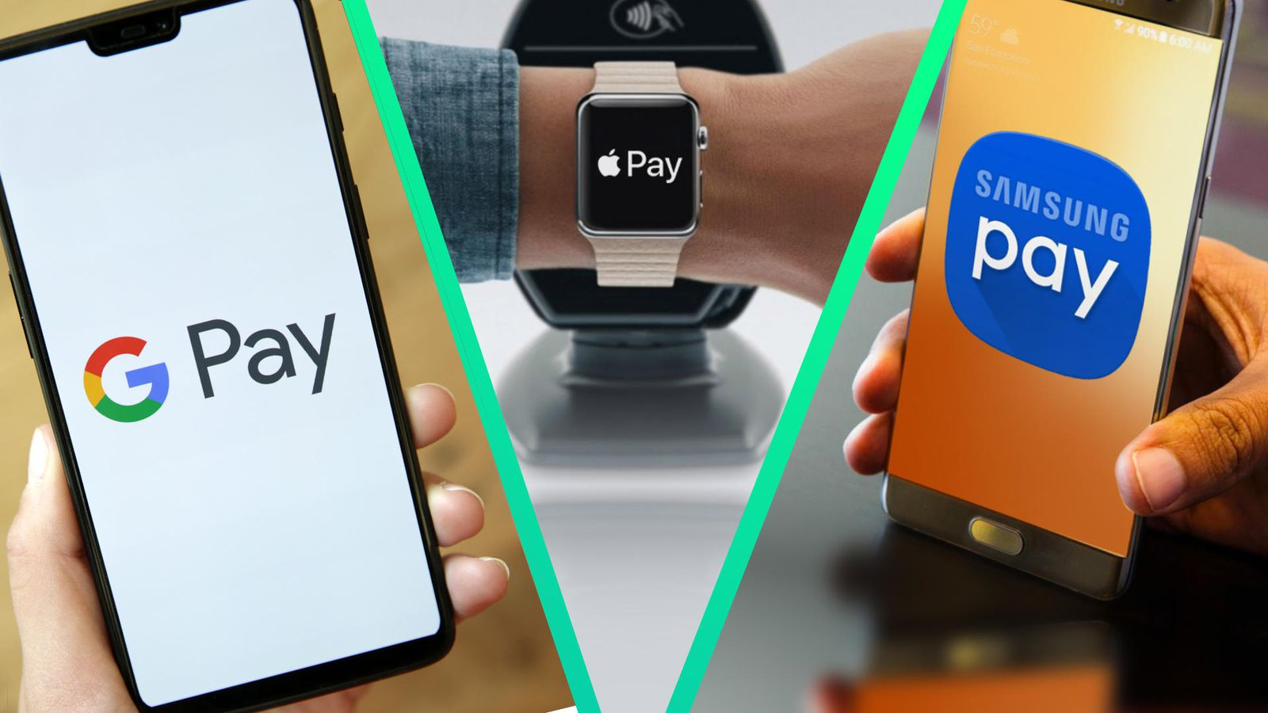

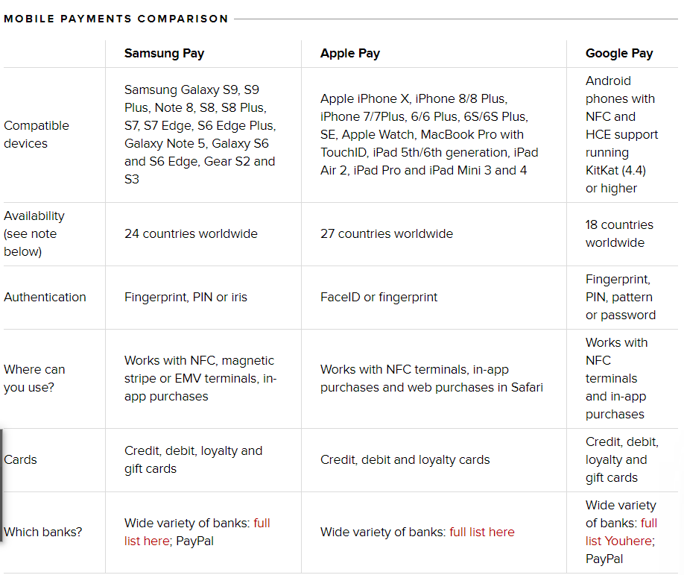The differences between the three services: (Savvides, 2018)

Other alternatives to these 3 payment services (Google Pay; Apple Pay and Samsung Pay) are Stripe, Braintree, and PayPal. They are all renowned payment platforms. Of course, they have differences and similarities, which in one table can be presented as: (tables taken from (A., n.d.) )

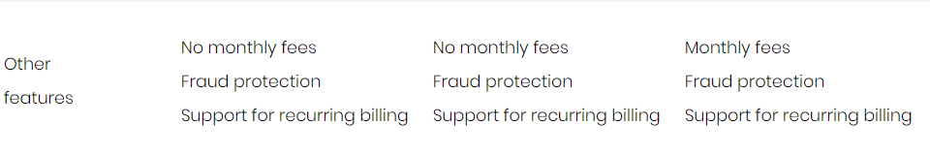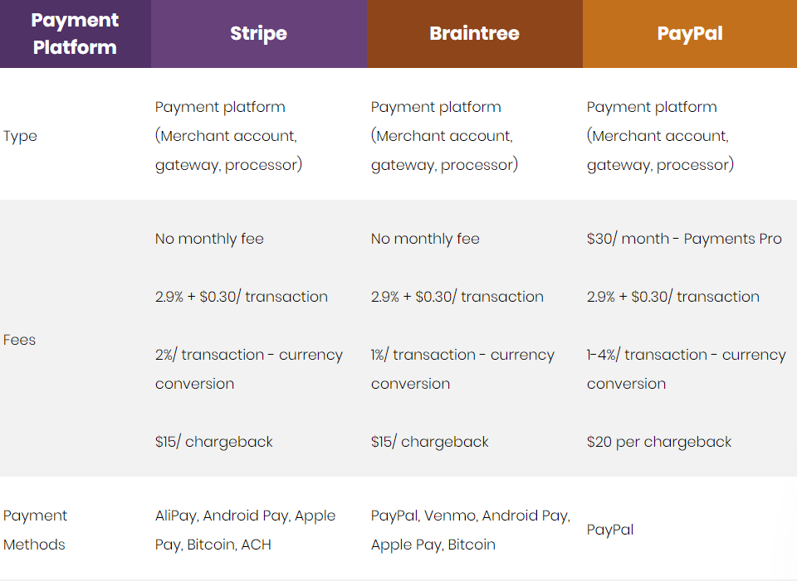

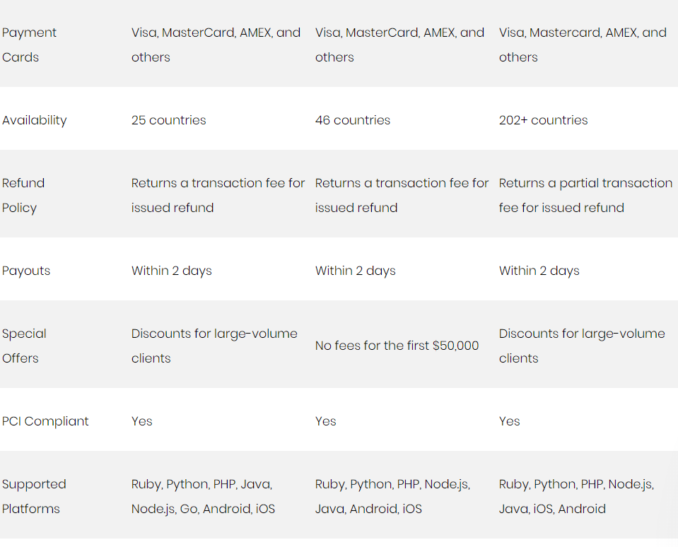

Subscriptions

How different applications handle subscriptions? Let’s give examples of Subscription based applications first (the following examples are applications that I am subscribed to or have been subscribed to before.)

* Amazon Prime (2 plans- Student; Basic)
* Kindle app
* Spotify ( 3 plans – Student; Family; Headspace + Premium)
* Netflix (3 plans – Basic; Standard; Premium)

The apps have:

* + Plans (different services provided)
  + Different payment methods (Debit or Credit Card; ESOS; GP; AP; SP; PayPal)
  + Monthly or yearly payment availabilities
  + Different Terms and Conditions

Let’s look at IWIC’s subscription web page:

If we go to <https://onlineshop.ucs.ac.uk/> , we will can easily make an account and subscribe for IWIC’s services.

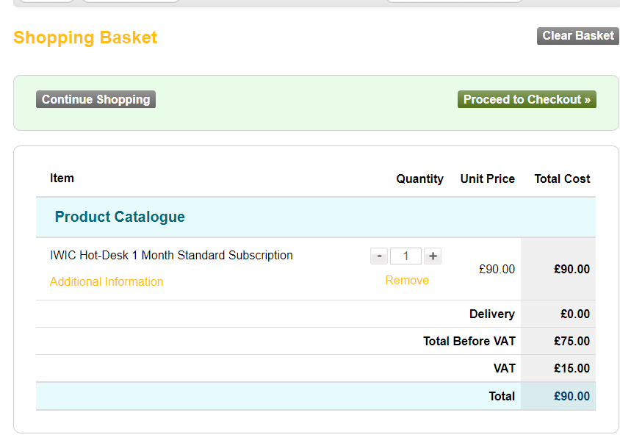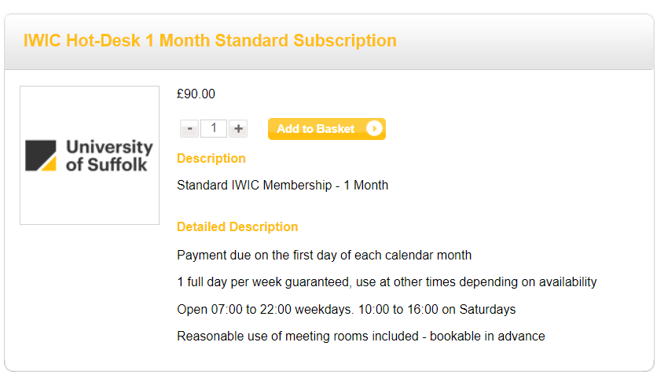 The “Shopping Basket”:

We can see that the payment can be done by Credit/Debit card:

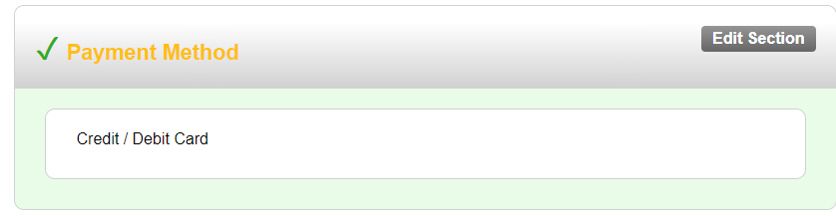

As we continue to scroll down, we can see the payment details that must be typed in by the user.

Also, if something is not written, or it is not ticked, the system will show an error, if the information is REQUIRED (\*) to be added by the customer.

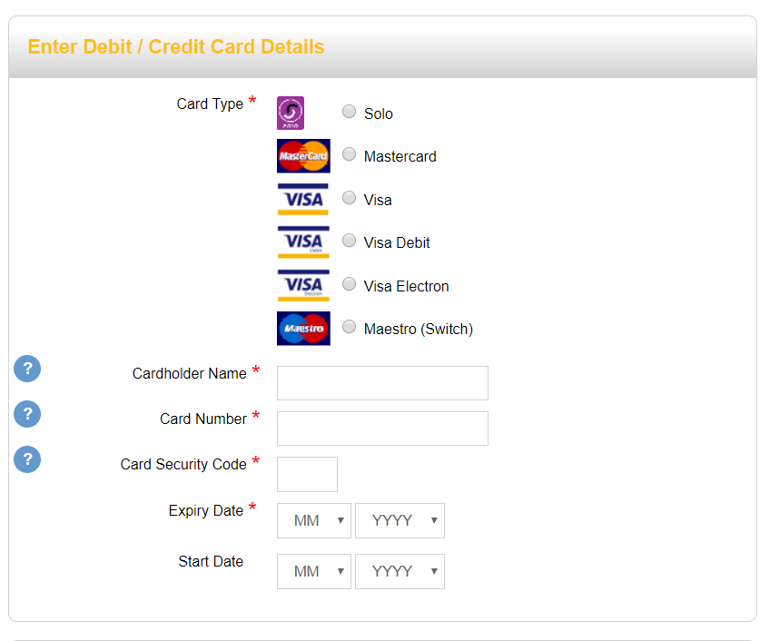

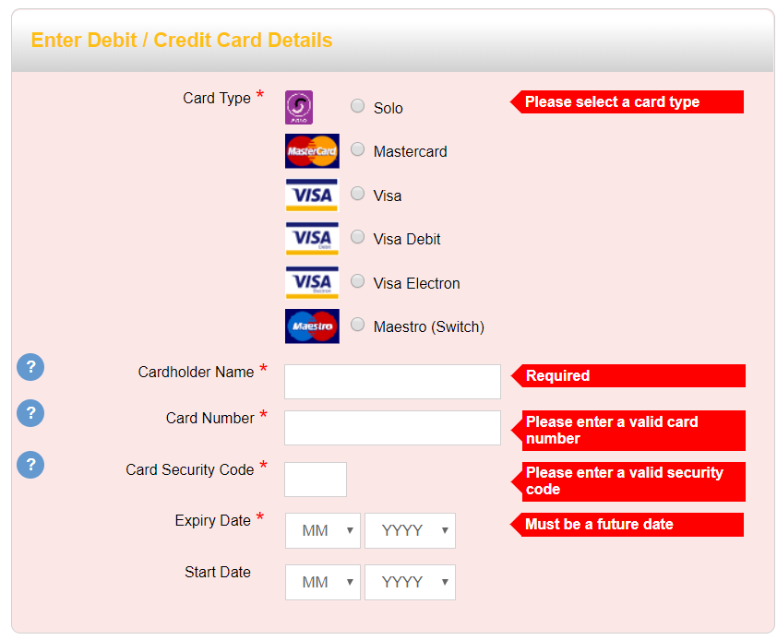

REFERENCES:

* Savvides, L. (2018). Apple Pay vs. Samsung Pay vs. Google Pay: What's the best mobile payment service?. [online] CNET. Available at: https://www.cnet.com/news/apple-pay-vs-samsung-pay-vs-google-pay-which-mobile-payment-system-is-best-chase-pay/ [Accessed 9 Oct. 2018].
* A., S. (n.d.). Stripe vs PayPal vs Braintree: How do these payment platforms compare?. [online] Rubygarage.org. Available at: https://rubygarage.org/blog/stripe-vs-braintree-vs-paypal-how-do-these-payment-platforms-compare [Accessed 9 Oct. 2018].
* Uzialko, A. (2018). Google Pay vs. Apple Pay vs. Samsung Pay. [online] business.com. Available at: https://www.business.com/articles/google-pay-vs-apple-pay-vs-samsung-pay/ [Accessed 9 Oct. 2018].

Pictures taken from:

* <https://mobilesyrup.com/2018/05/17/google-pay-mobile-tickets-transactions/>
* <https://australia.googleblog.com/2018/02/more-than-just-way-to-pay-new-google_21.html>
* <https://support.apple.com/en-ca/apple-pay>
* <https://www.engadget.com/2018/04/23/samsung-pay-ready-to-use-paypal-wallet/?guccounter=1>
* <https://www.cnet.com/news/apple-pay-vs-samsung-pay-vs-google-pay-which-mobile-payment-system-is-best-chase-pay/>